Write a C++ program that uses nested for loops to generate a multiplication table from 1 × 1 to 10 × 10. Use the “tab” escape sequence (”\t”) to format the table properly.
Input

// ECE 2305 - Tutorial 16
// Nested FOR Loops
#include<iostream>
using namespace std;

int main()
{
cout << "ECE 2305 - Tutorial 16" << endl;
cout << "Nested FOR Loops" << endl;
cout << endl;

cout << "\t1\t2\t3\t4\t5\t6\t7\t8\t9\t10" << endl;
for (int m = 1; m <= 10; m++)
{
cout << m << " \t";
for (int n = 1; n <= 10; n++)
cout << m * n << " \t";
cout << endl;
}
cout << endl;
system("pause");
return 0;
}
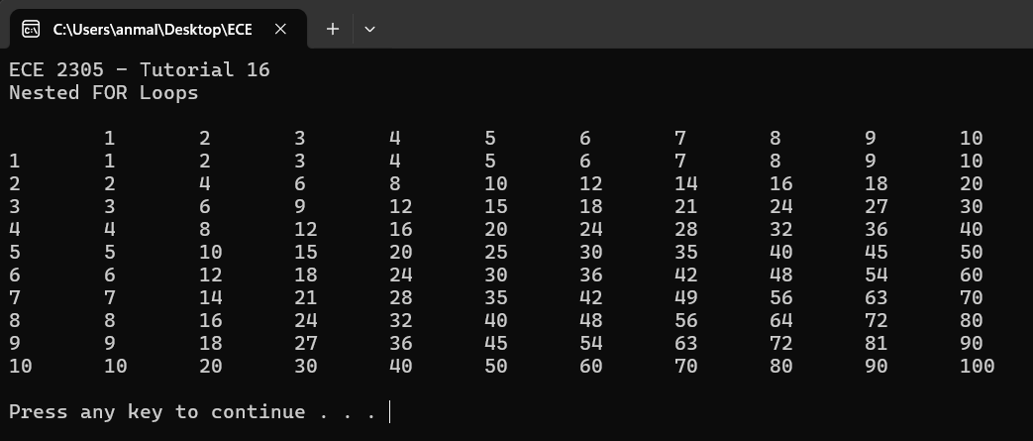
Output

